DROP-OFF PROCEDURES
Please share this information with all the drivers in your family.

- Students may be dropped off after 8:00 a.m. on the sidewalk in front of and to the right of the rear canopy. Students arriving to school early for extra help may be dropped off at 7:30 a.m. at the rear canopy entrance. Please use the entire length of the sidewalk for drop-off to enable all students to arrive at their classes on time. Please refer to the diagram below.
- DO NOT drop off students:
  - in the lower parking lot, other than at the designated sidewalk
  - anywhere in the upper parking lot
  - at the front entrance of the school
- If your child has a physical disability, he/she may be dropped off and picked up at the front entrance ONLY if you have a pass from the nurse or the main office.

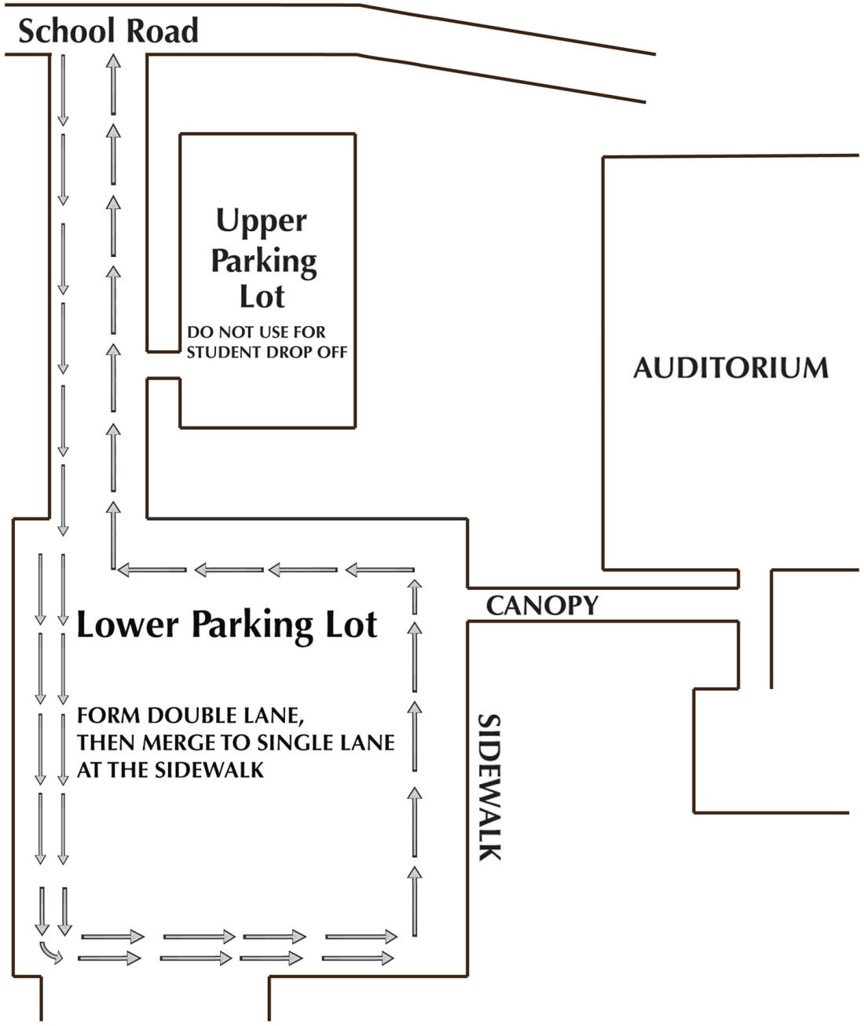

PICK-UP PROCEDURES
Please share this information with all the drivers in your family.

- The procedure for NORMAL student pick-up is the same as the drop-off procedures for students not taking the bus. Students will be released from classes after the bell rings at 2:50 p.m. They will leave the building through the rear canopy exit and can be picked up along the sidewalk in front of and to the right of the canopy. Please use the entire length of the sidewalk for pick-up. DO NOT attempt to drive through the lower parking lot aisles to pick up your child - it is not safe and it blocks traffic flow. Please refer to the diagram below.
- EXPRESS pick-up procedure for students who need to be picked-up right at 2:50 p.m. - Parents/drivers must park in the upper parking lot or in the lower parking lot and walk to the canopy area to meet their students. Please follow the directions noted below.
- DO NOT pick-up students in the lower parking lot, other than at the designated sidewalk. Do not pick up students from the front entrance of the school unless you are making an office pick-up prior to 2:50 p.m.
